Benchmark functions:
We will now utilize two benchmark functions to validate and test the ADAM optimizer implementation:
- The Rosenbrock function
- The Beale function
Both are standard test functions in the optimization literature with known global minima, making them ideal for verifying that the optimizer converges correctly.
For each function, we document the mathematical formulation, the analytical gradient passed to the optimizer, the hyperparameters used, and the results obtained.

Rosenbrock Function:
Objective Function:
The mathematical formation of the Rosenbrock function is given below:
f(x₁, x₂) = (1 − x₁)² + 100 · (x₂ − x₁²)²
Gradient:
The gradient is derived analytically by differentiating f with respect to both the variables i.e. x₁ and x₂:
∂f/∂x₁ = −2·(1 − x₁) − 400·x₁·(x₂ − x₁²)
∂f/∂x₂ = 200·(x₂ − x₁²)
This gradient is passed directly to the ADAM optimizer as a function handle. No numerical approximation or adjoint method is needed for this simple expression.
MATLAB Implementation:
The function and gradient are defined as anonymous function handles:
f = @(x) (1 - x(1))^2 + 100 * (x(2) - x(1)^2)^2;
g = @(x) [ -2*(1-x(1)) - 400*x(1)*(x(2) - x(1)^2);
200*(x(2) - x(1)^2) ];
Minimum of the function:
The global minimum already known and is located at:
x* = (1, 1), f(x*) = 0
Hyperparameters
Parameter | Value
w₀ | (−1.5, 2.0)
α | 0.01
max_iter | 15 000
β₁ | 0.9
β₂ | 0.999
ε | 1 × 10⁻⁸
tol | 1 × 10⁻⁵

Results
The ADAM optimizer successfully converges to the global minimum in 4145 iterations. The result is verified against MATLAB's fminsearch function, which uses the Nelder-Mead simplex method.
Method | x₁ | x₂
Known minimum | 1.0000 | 1.0000
ADAM optimizer | 1.0000 | 1.0000
fminsearch verification | 1.0000 | 1.0000

Convergence Plot
The left plot shows the optimization trajectory on the Rosenbrock contour. The blue square marks the starting point (−1.5, 2.0) and the green star marks the global minimum (1, 1). The right plot shows the loss value on a logarithmic scale over 4500 iterations.
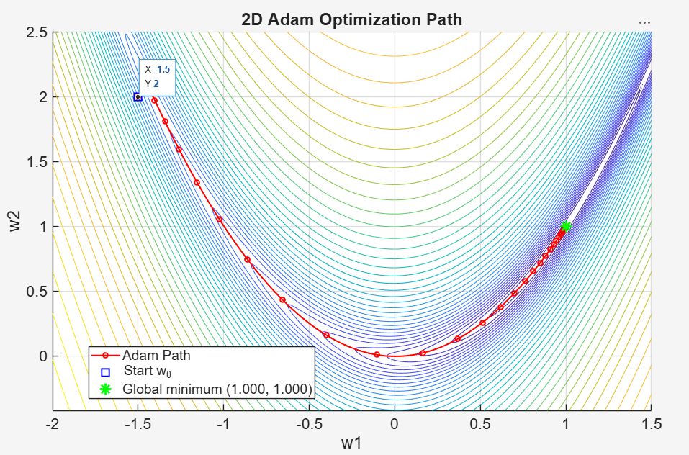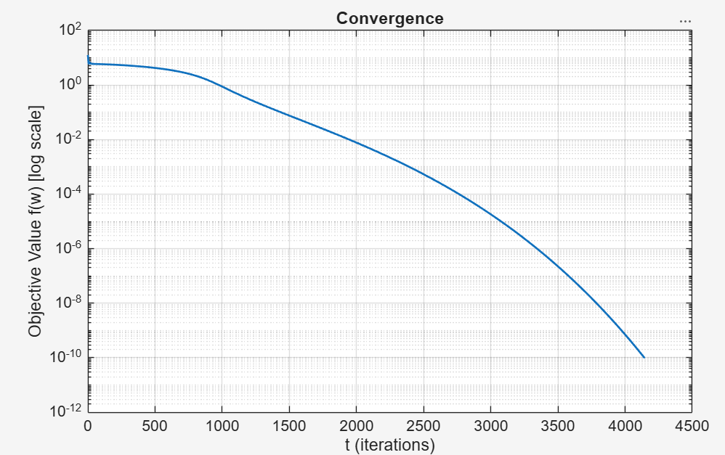
The trajectory clearly shows Adam navigating the narrow banana-shaped valley. The loss drops rapidly in the first 1500 iterations as Adam locates the valley, then decreases more slowly as it traverses the curved floor toward the minimum.
Beale Function:
Objective Function:
The mathematical formation of the Baele function is given below:
f(x₁, x₂) = (1.5 − x₁ + x₁x₂)² + (2.25 − x₁ + x₁x₂²)² + (2.625 − x₁ + x₁x₂³)²
Gradient:
The gradient is derived analytically by differentiating f with respect to both the variables i.e. x₁ and x₂:
∂f/∂x₁ = 2x₁x₂⁶ + 2x₁x₂⁴ − 4x₁x₂³ − 2x₁x₂² − 4x₁x₂ + 6x₁ + (21/4)x₂³ + (9/2)x₂² + 3x₂ − 51/4
∂f/∂x₂ = 6x₁²x₂⁵ + 4x₁²x₂³ − 6x₁²x₂² − 2x₁²x₂ − 2x₁² + (63/4)x₁x₂² + 9x₁x₂ + 3x₁
This gradient is passed directly to the ADAM optimizer as a function handle. No numerical approximation or adjoint method is needed for this simple expression.
MATLAB Implementation:
The function and gradient are defined as anonymous function handles:
f = @(x) (1.5 - x(1) + x(1)*x(2))^2 + (2.25 - x(1) + x(1)*x(2)^2)^2
+ (2.625 - x(1) + x(1)*x(2)^3)^2;

g = @(x) [2*x(1)*x(2)^6 + 2*x(1)*x(2)^4 - 4*x(1)*x(2)^3 ...
- 2*x(1)*x(2)^2 - 4*x(1)*x(2) + 6*x(1) ...
+ 21/4*x(2)^3 + 9/2*x(2)^2 + 3*x(2) - 51/4;
6*x(1)^2*x(2)^5 + 4*x(1)^2*x(2)^3 ...
- 6*x(1)^2*x(2)^2 - 2*x(1)^2*x(2) - 2*x(1)^2 ...
+ 63/4*x(1)*x(2)^2 + 9*x(1)*x(2) + 3*x(1)];
Minimum of the function:
The global minimum already known and is located at:
x* = (3, 0.5), f(x*) = 0
Hyperparameters
Parameter | Value
w₀ | (1, 0)
α | 0.01
max_iter | 15 000
β₁ | 0.9
β₂ | 0.999
ε | 1 × 10⁻⁸
tol | 1 × 10⁻⁵

Results
The ADAM optimizer successfully converges to the global minimum in 2491 iterations. The result is verified against MATLAB's fminsearch function, which uses the Nelder-Mead simplex method.
Method | x₁ | x₂
Known minimum | 3.0000 | 0.5000
ADAM optimizer | 3.0000 | 0.5000
fminsearch verification | 3.0000 | 0.5000

Convergence Plot
The left plot shows the optimization trajectory on the Beale function contour. The blue square marks the starting point (1, 0) and the green star marks the global minimum (3, 0.5). The right plot shows the loss value on a logarithmic scale.
